*1 INTRODUCTION*

1.1 *overview*

*This report delves into the fascinating realm of* *business expenses and provides a visual exploration of the various expenditures incurred by different businesses. It showcases the distribution of expenses, identifies key cost drivers, and highlights areas of potential optimization or concern. The visual representations allow for intuitive analysis, facilitating a deeper understanding of expenditure patterns and their implications for business performance. Decision-makers, financial analysts, and stakeholders can gain valuable insights into the financial health of businesses, identify areas of inefficiency or opportunity, and make informed decisions to optimize resources and drive growth. To Extract the Insights from the data and put the data in the form of visualizations, Dashboards and Story we employed Tableau tool.*

*1.2 PURPOSE*

*The purpose of an estimate is to help a business plan for and successfully complete projects.*

*Estimates help small businesses draw up budgets, evaluate cash flow and manage client expectations. Estimates also help a business owner decide on the overall scope of a project (what it* *does and doesn’t include) while also nailing down all the fine details that will go into said project.*

*These are all things which make projects run more smoothly and make sure a company continues to get new clients and business. Though an estimate may be extra work upfront, it will pay off in successful projects and more* [*revenue*](https://www.freshbooks.com/glossary/accounting/revenue) *down the line.*

*Simply put, small businesses use estimates when a client asks for one. Chat with your client first to determine exactly what they want. Are they asking several companies to cost out a project? You need to provide them with a bid. Do they want in-depth information on your company and its past work. They’re looking for a proposal.*

*An estimate, on the other hand, provides clients with approximate costs based on the current project scope while acknowledging things could change. We need to estimate so we know fairly accurately what the project involves and so we can then communicate that to our client.*

*Estimating never be 100 percent accurate. An estimate is exactly that—an approximation. It’s not an exact science.*

*Still, it’s important for an estimate to be as accurate as possible so you and the client both understand exactly what you’re getting into.*

2 PROBLEM DEFINITION AND DESIGN THINKING

*2.1 EMPATHY MAP*

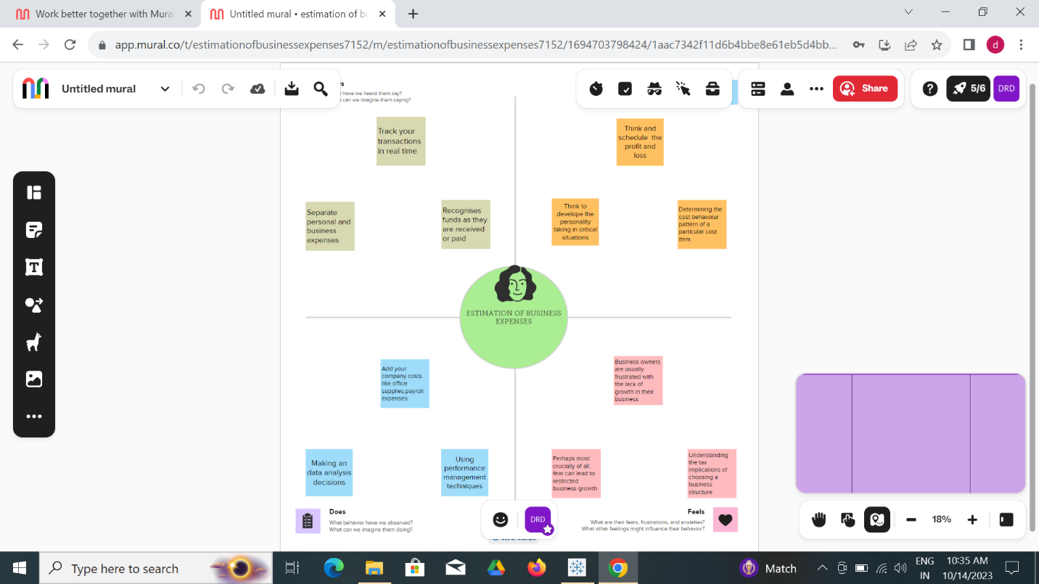

*2.2 IDEATION AND BRAINSTORMING MAP*

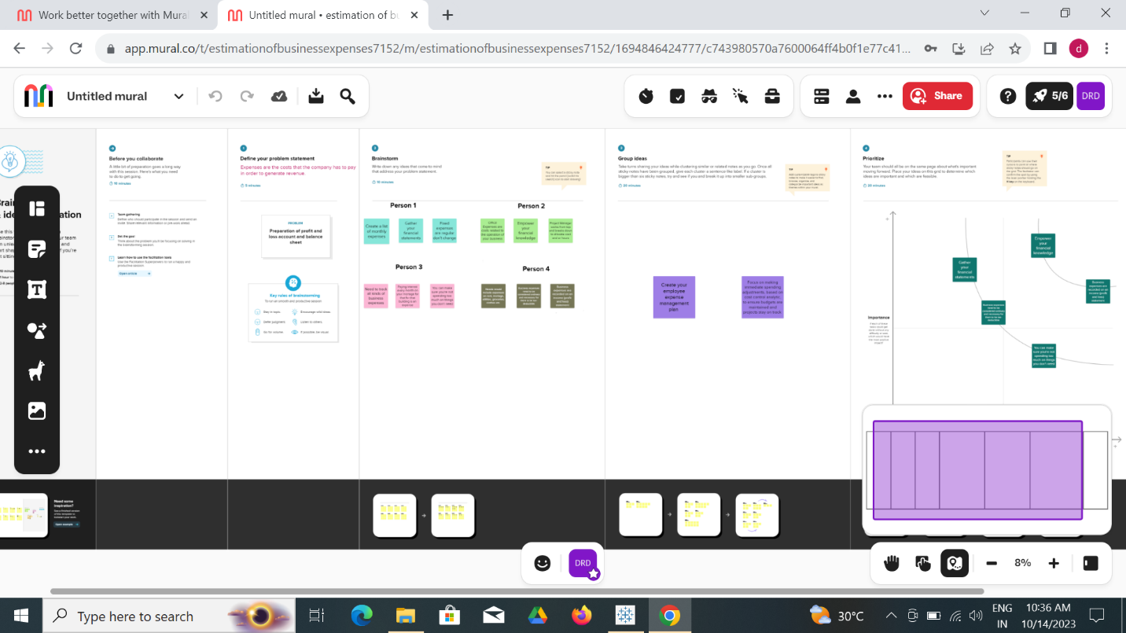

3. RESULT

Dashboard 1 (screenshot): Expense Breakdown

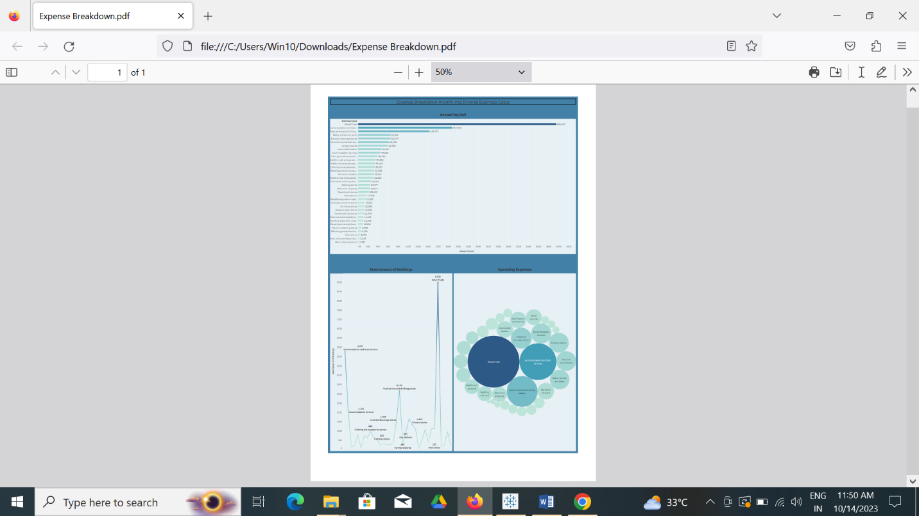

*Dashboard 2 (screenshot): Business Expenditure Overview*

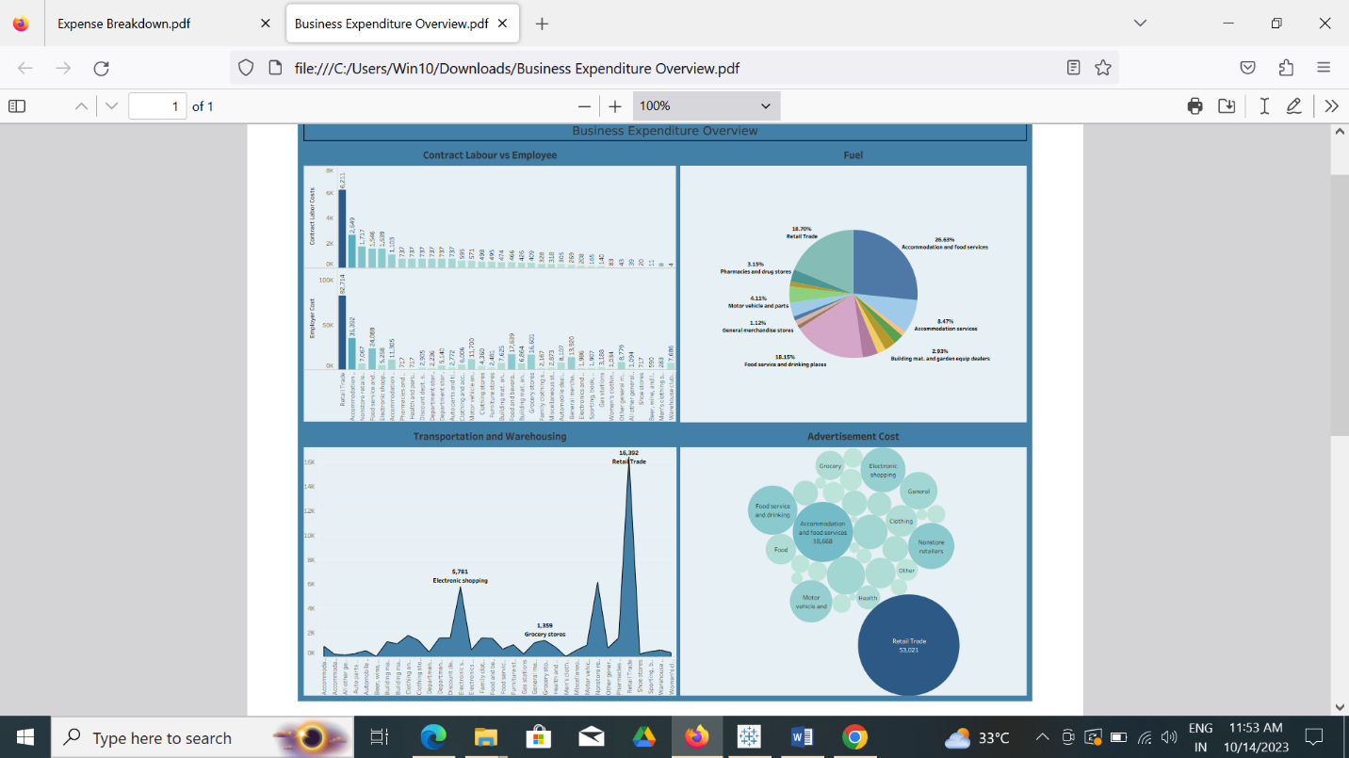

*Dashboard 3(screenshot): Expense Insights*

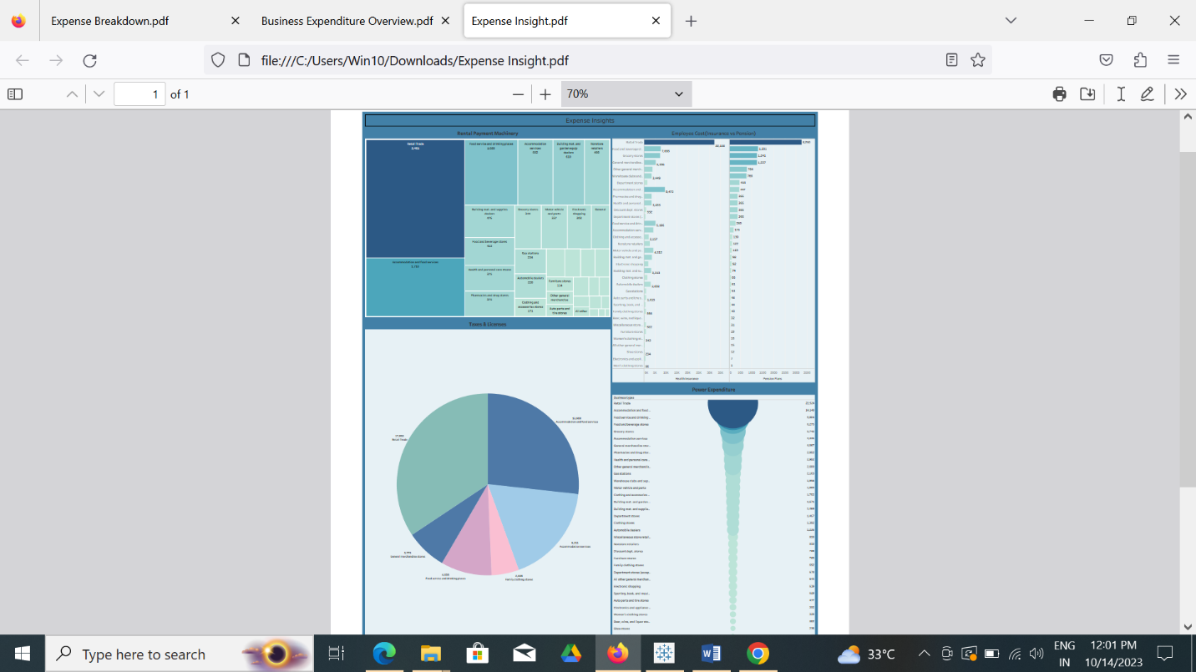

*Story 1(screenshot): Expenses 1*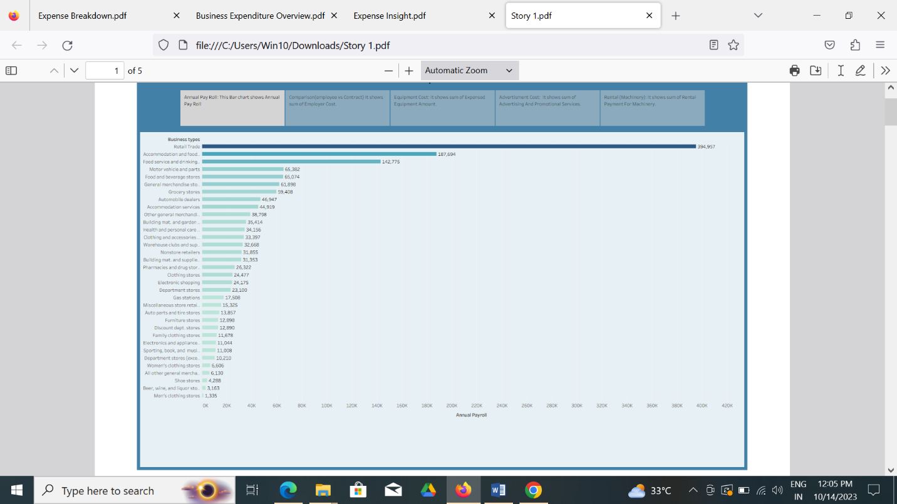

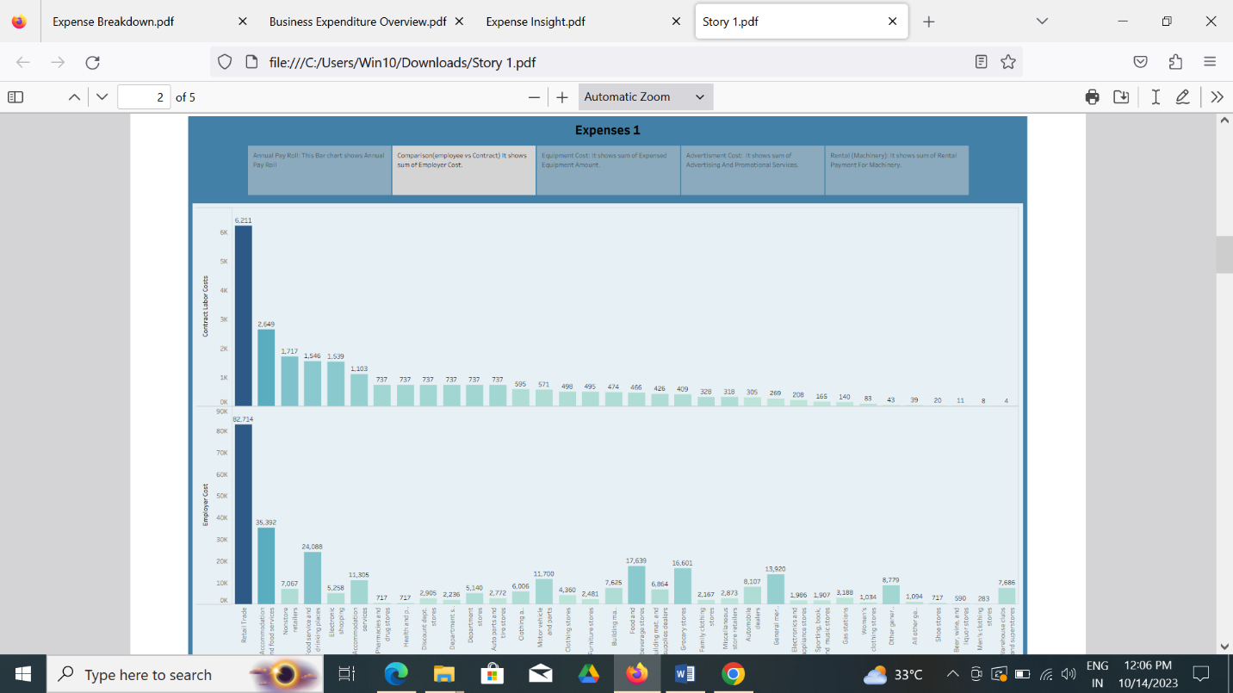

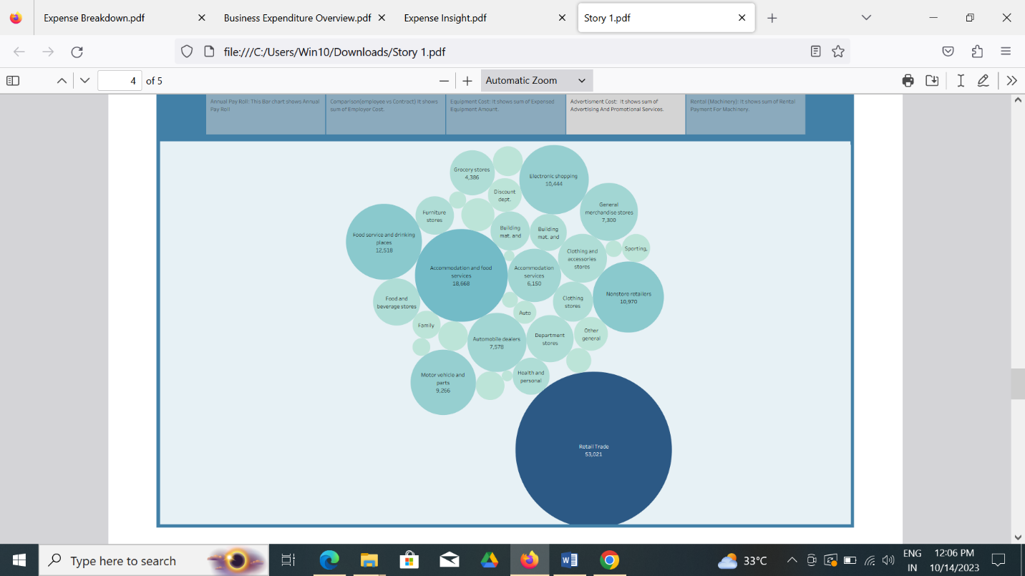

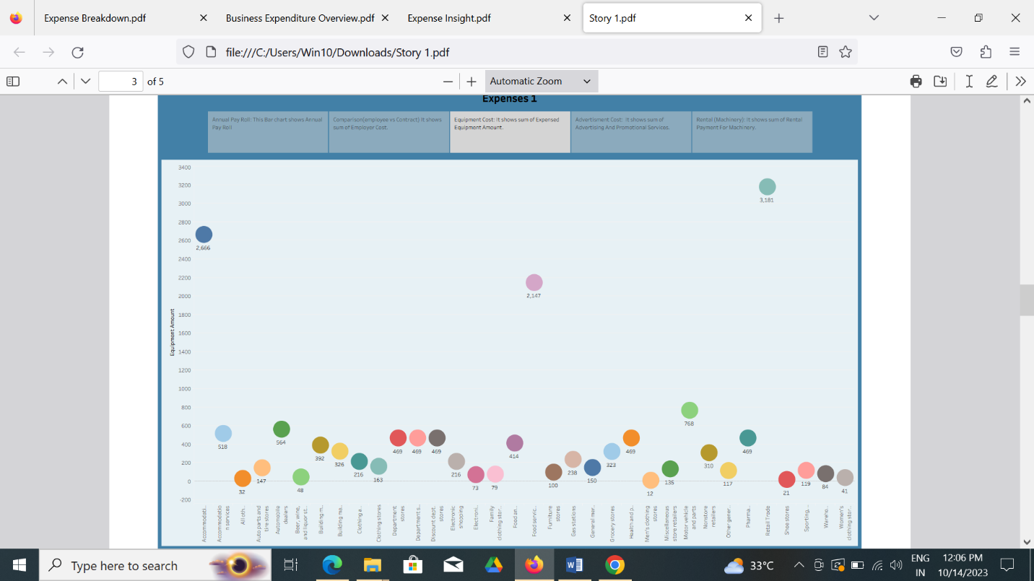

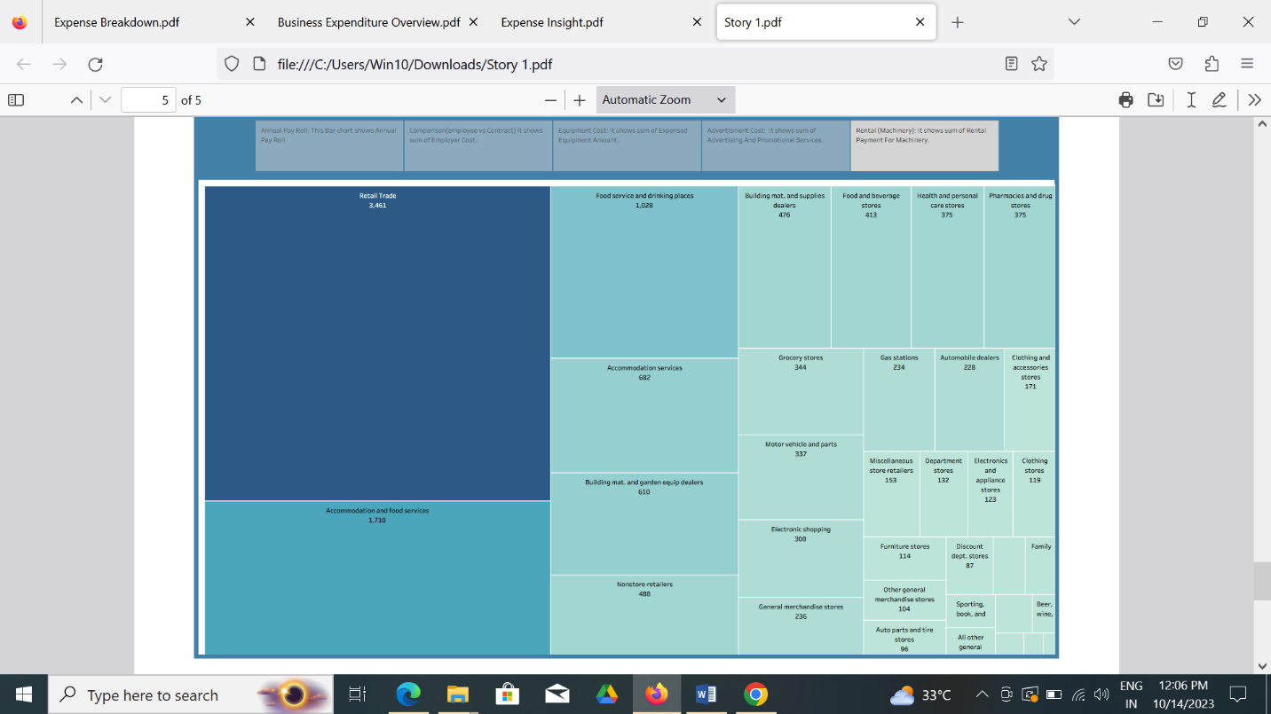

Story 2(Screenshot): Expenses 2

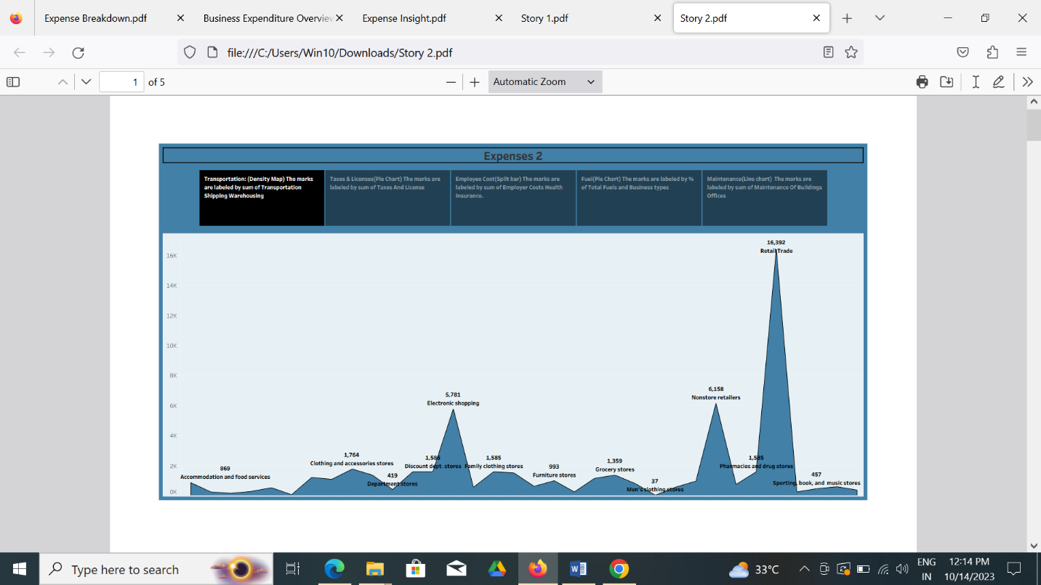

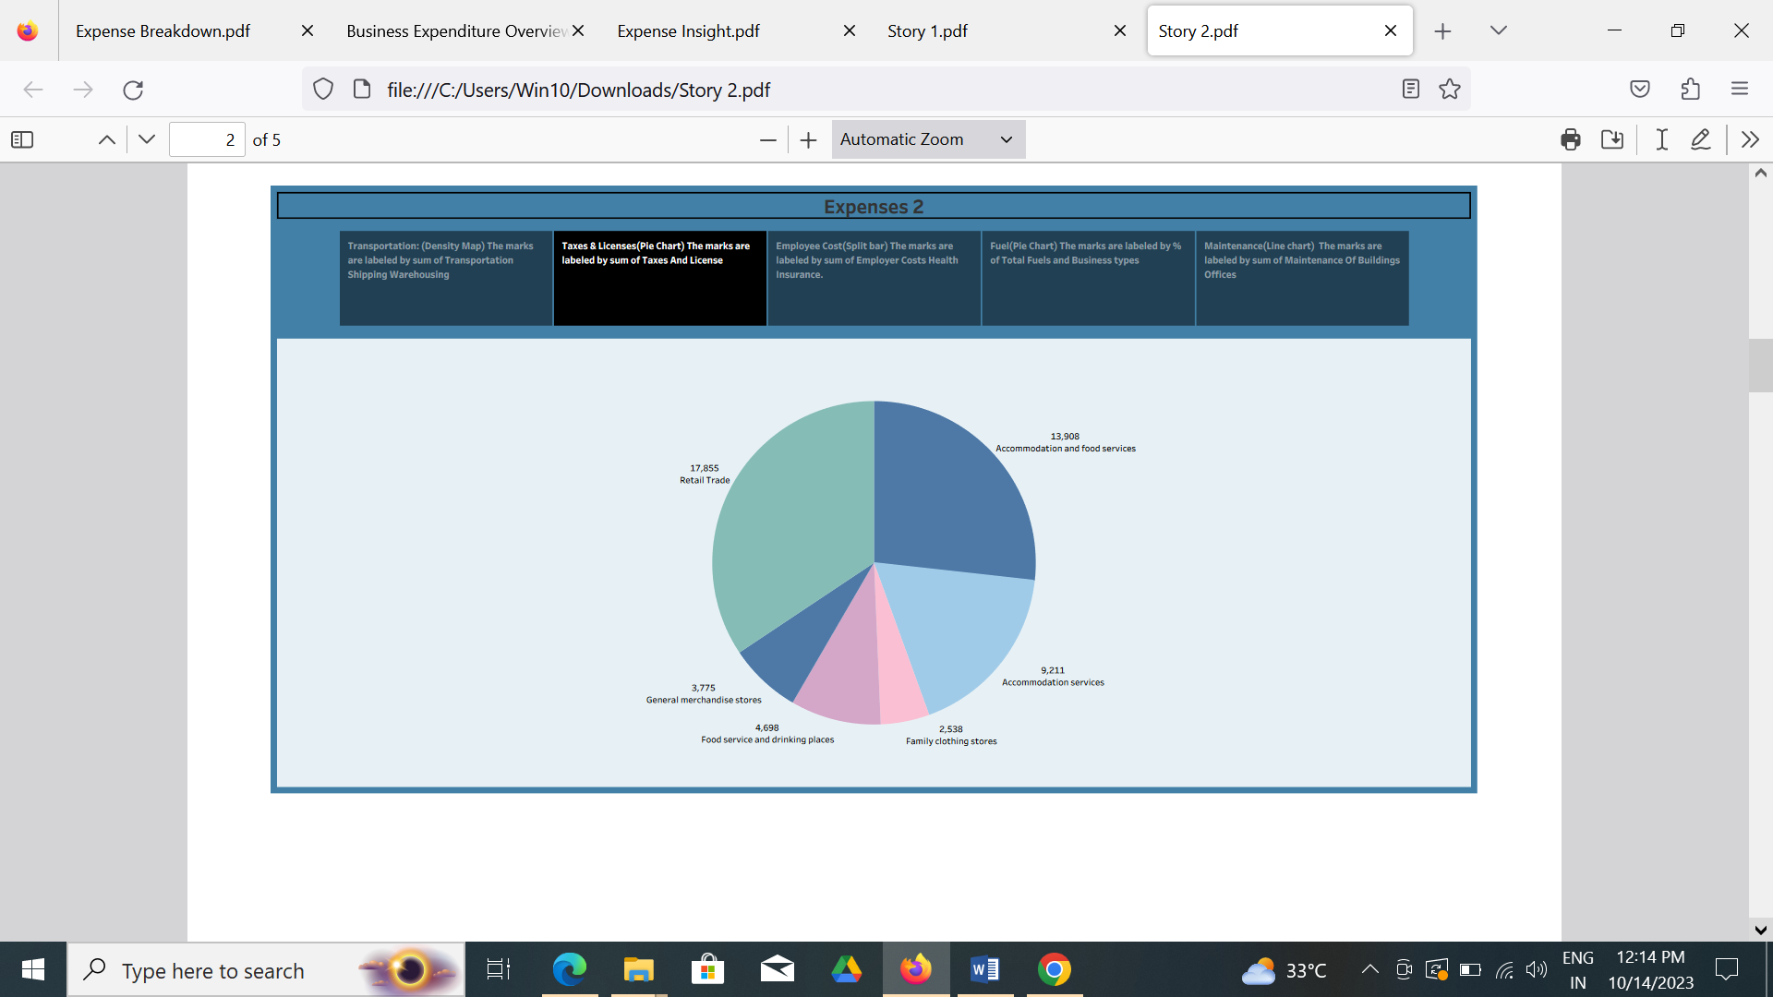

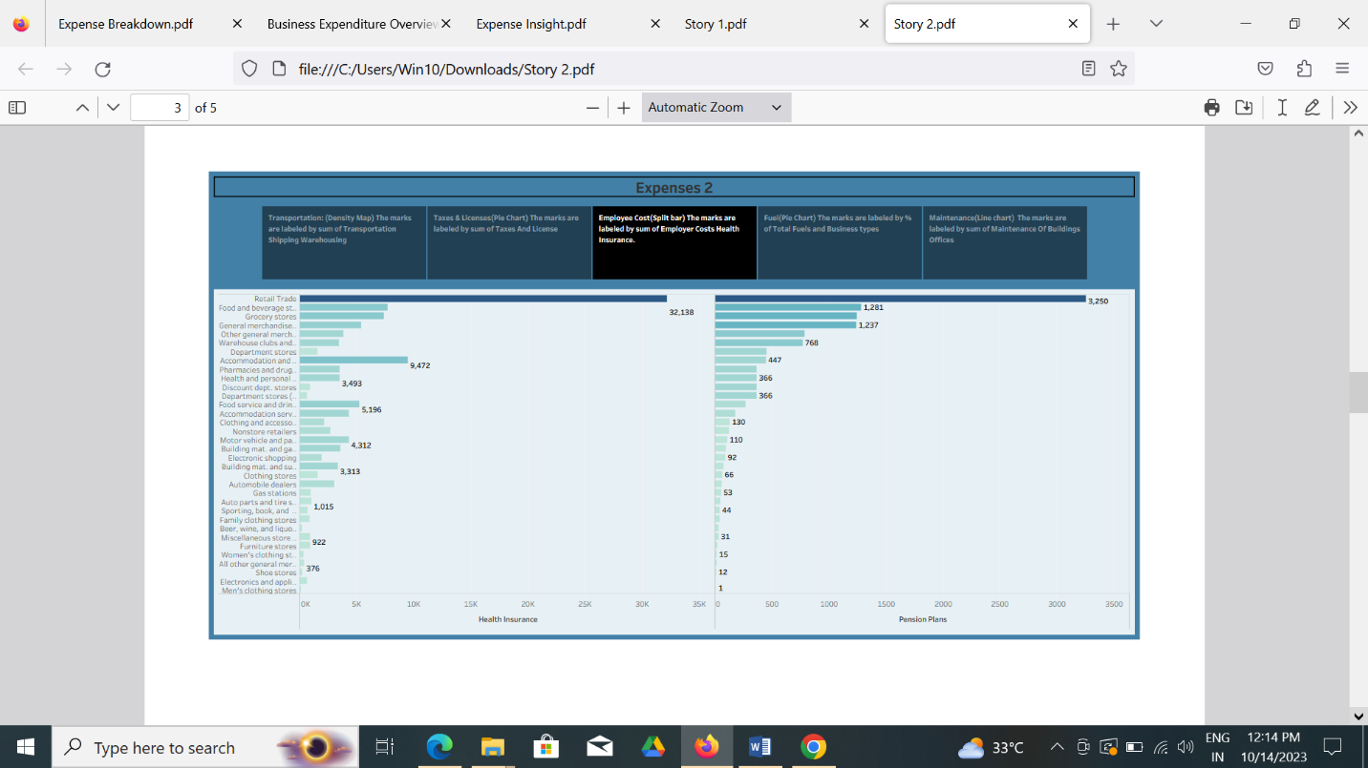

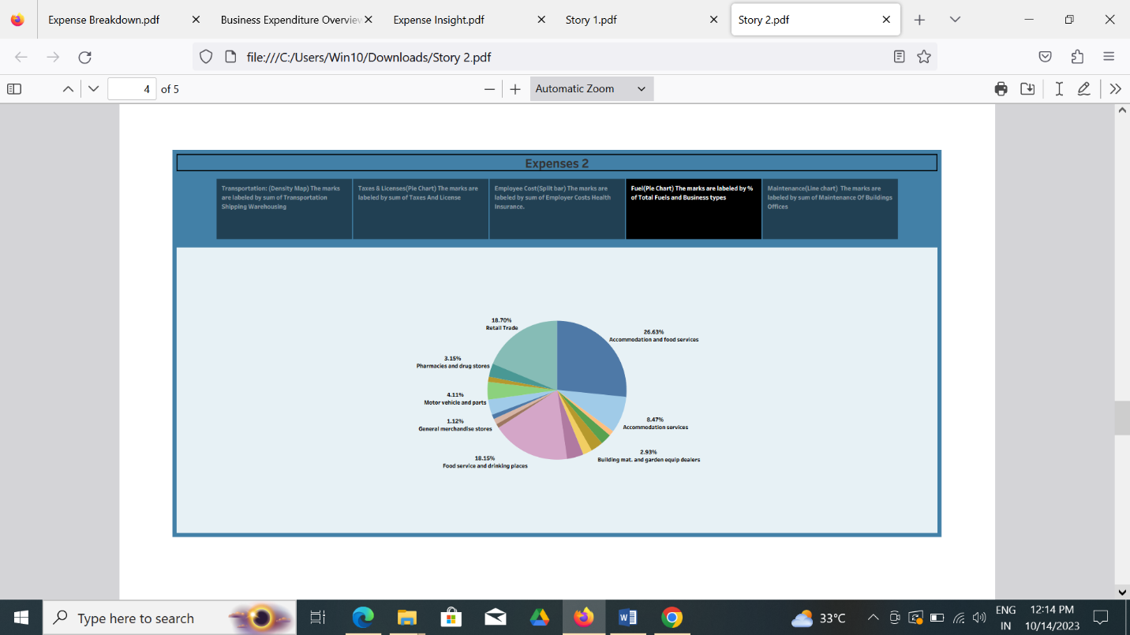

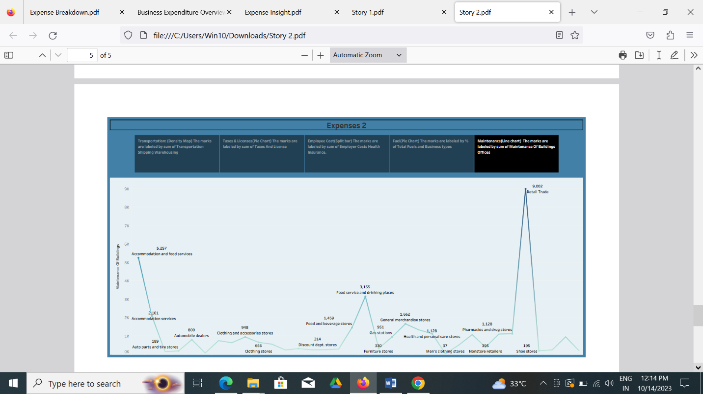

4. *ADVANTAGES AND DISADVANTAGES*

*Advantages:*

*There are several advantages estimation of business expenses.*

*Cost-benefit analysis is a process that project managers and business executives use to determine the expenses and incentives of a major company project. When companies perform a cost-benefit analysis, they calculate the costs and benefits for the project or decision and determine which calculation is larger. If the benefits exceed the costs, the project or decision is generally a positive one for the company to make. However, if the costs exceed the benefits, the company often evaluates that project's plan and determines if there's a way to adjust it or save money.*

*Companies and businesses often use a cost-benefit analysis to determine and evaluate all the expenses and revenues that a project might generate. The analysis helps companies examine the feasibility of the project in terms of finances and other important factors, such as opportunity costs. Opportunity costs consider alternative benefits that the company might give up if they proceed with the project or project decision. Once the company understands all of its major costs and benefits, it can better understand the decision's pros and cons. However, it doesn't always make the decision perfectly clear*

*A cost-benefit analysis is a systematic process that businesses use to analyze which decisions to make and which to forgo. The cost-benefit analyst sums the potential rewards expected from a situation or action and then subtracts the total costs associated with taking that action. Some consultants or* [*analysts*](https://www.investopedia.com/terms/a/analyst.asp) *also build models to assign a dollar value on intangible items, such as the benefits and costs associated with living in a certain town.*

*Disadvantages:*

*Some disadvantages of the Engineering Cost Estimating method include:*

* *It can be expensive to implement and it is time-consuming*
* *It is not flexible enough to answer what-if questions*
* *New estimates must be built for each alternative*
* *The product specification must be well-known and stable*
* *All product and process changes must be reflected in the estimate*

*As estimators, you need to forecast the cost of completing a project with a defined scope. This is the main component of project cost management, which involves planning, monitoring, and controlling the project’s monetary costs.*

*To do this effectively, you need to:*

* *Have knowledge and experience in cost estimating.*
* *Understand the project scope, resources, risks, and quality.*
* *Apply standard estimation techniques, tools, and best practices.*

*Having knowledge and experience in cost estimating can help you keep your budget under control. You can also avoid overspending by detecting and managing potential cost factors and uncertainties.*

*You can increase your profit margins by finishing the project within budget and meeting profitability goals. Consequently, you’ll be able to improve stakeholder satisfaction and increase the credibility of your construction company.*

5 APPLICATIONS

*The purpose of cost estimation is to give project stakeholders accurate information concerning the related project costs. It is easier to make lasting decisions if there is information to back them up. Cost estimation also gives clients value-aided options and helps clients minimize expenses.*

*Direct costs refer to specific costs meant for a product, department, or project. They are the costs that are immediately linked with the construction of a project. Such prices include labor and materials. These costs are also variable and fluctuate depending on the market conditions. Below are some of the direct costs in cost estimation.*

*These are the costs of the materials and equipment necessary for a project's success. The costs vary depending on market conditions. Cost estimators also look at historical data and use it to predict expected buying prices.*

*Unlike direct costs, indirect costs are not directly linked to the construction work. They can be either variable or fixed costs. They include transport, administrative, and building temporary structures, permits, design, and legal fees. Overhead costs which cannot be directly charged in a specific project but are necessary to support overall project activities are also grouped as direct costs.*

*Estimation helps in cost control in a project. Cost estimation provides a project baseline for measuring variances from the initial costs. After measuring variances, stakeholders can then make decisions for corrective action to attain minimal costs. Cost control also helps in scope change management. Any changes to the initial costs are recorded to make it easy to continually forecast the expected final costs. This assessment of cost controls helps the project to stay on course and avoid budget overruns.*

7 CONCLUSION:

*The strategic cost management approach presents a compelling and efficacious solution for enhancing cost management in manufacturing companies, facilitating sustainable development, and fostering integrated systems. By effectively addressing cost stickiness and diligently monitoring product life cycles, organizations can substantially improve their decision-making processes, thereby attaining a distinct competitive advantage in today's fast-evolving business landscape. Embracing this strategic paradigm empowers enterprises to adeptly navigate the challenges of global competition, effectively respond to dynamic market demands, and establish a robust foundation for sustained long-term success and enhanced profitability. Through the adoption of strategic cost management, companies are well-positioned to optimize resource utilization, drive operational efficiency, and make prudent strategic choices, leading to enduring success and progressive growth in the highly competitive business environment.*

7 FUTURE SCOPE:

*A Tableau Developer uses the Tableau platform for data analysis, data visualization, and the BI process of an organization. They are responsible for developing, maintaining, and managing a BI system for an organization. This is a highly sought-after job as more and more companies are opting for Data Analytics.*

*Business analytics, widely known for its diagnostic, predictive and prescriptive prowess, has gained tremendous traction in the last year as governments and*[*healthcare*](https://www.upgrad.com/blog/healthcare-project-ideas-topics/)*institutions embraced this progressive approach to overcome organisational obstacles and provide long-lasting solutions*

*\*\*THIS IS MY PROJECT DOCUMENTATION\*\**